Algebra 3-4 Name: ____________________

Chapter 2 Test Block: ________

For problem 1 – 2, choose the slope of the line passing through the given points.

1. (3, 2), (-4, 3) 2. (-5, -6), (-5, -9)

A. –7 A. 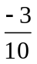
B. –1 B. 0
C. 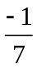 C. 1
D. 2 D. undefined

For problems 3 – 4, tell whether the lines are parallel, perpendicular, or neither.

3. Line 1: through (3, 4) and (1, 6) 4. Line 1: through (0, -2) and (2, -2.5)
Line 2: through (-1, 0) and (3, 5) Line 2: through (-4, 6) and (0, 5)

For problem 5, select the slope-intercept form of the line with the given information.

5. 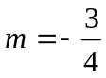, 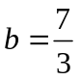

A. 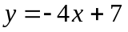

B. 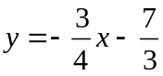

C. 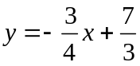

D. 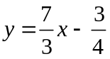

For problem 6 – 8, write the equation of the line in point-slope form AND slope-intercept form.
6. Through the point (9, 3) with slope 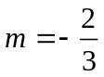.
Point-slope: _____________

Slope-intercept: _________

7. Through the points (1, 4) and (2, -8).

Point-slope: _____________

Slope-intercept: _________

8. The line passes through (2, 6) and is perpendicular to y = 2x – 3.

Point-slope: _____________

Slope-intercept: _________

For problem 9, graph the function. Identify the domain and range. Then tell whether the relation is a function.

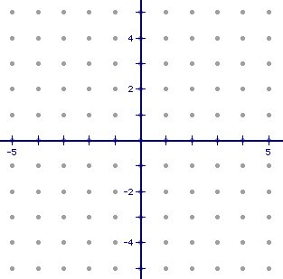
9. a. b. Domain: _________
Input | Output
0 | -4
0 | 4
2 | -2
2 | 3
4 | -1
4 | 1
c. Range: ___________

d. Is the relation a function ?
Yes or No

For problems 10 – 12, graph the function.
10. x = -2 11. y = -2x + 5

12. y = x

For problem 13, find the x and y intercepts. Then graph the equation.

13. 9x + 6y = 12

x-intercept: _____ y-intercept: _____

For problem 14, state whether the function is linear. Then evaluate the equation for the given value of x.

14. If 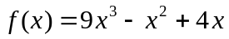

- Is the function linear?

b. Evaluate 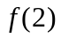.

For problem 15, select the correct answer.

15. Which is a solution to the inequality 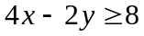?

A. (-5, 5)

B. (-2, -9)

C. (3, 3)

D. (4, 10)

For problems 16 – 18, graph the inequalities.

16. y > 4 17. 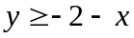

18. 2x + y < -1

For problems 19 – 21, use the given information to answer the problems.

19. In order for this year’s star basketball player to break the school record for most points (excluding free throws), he must score at least 36 points. The points may be scored by two-point shots and three-point shots. Write an inequality that represents the number of two and three-point shots he needs to break the record. Then Graph the inequality.

20. The school theatre group is selling cookies and cupcakes to raise money for the upcoming musical. The cookies are $1.50 per bag and the cupcakes are $2.25 per bag. Each student has a goal to sell $25 worth of cookie and cupcake bags. Write a model that shows the number of cookie and cupcake bags that each student must sell. Then graph the model.

21. Tim is trying to lose weight for wrestling. He begins the season at 160 pounds. At the end of the fourth week of practice, he weighs 153 pounds. What is Tim’s average change in weight?

